Name: ________________________________________ Date: ____________________________

PreCalculus: Calculus Intro Unit – HW C6-2 Visca

In Exercises 1–6, find the indefinite integral.

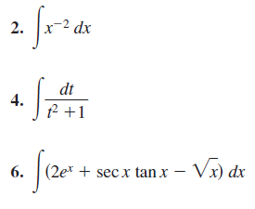

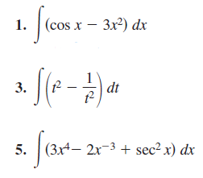

In Exercises 17–24, use the indicated substitution to evaluate the integral.





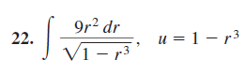

In Exercises 53–66, make a u-substitution and integrate

